**Question :** SunFire Petroleums produces two types of fuels from 3 different types of oils. Cost and availability of oils is given in the Excel Sheet. Fuel type A should include at least 30% from oil 1, at most 50% from oil 2 and at least 30% from oil 3. Fuel type B should include at most 30% from oil 1, at least 50% from oil 2 and at most 30% from oil 3. Selling price of fuel type A is 1.1$ and Fuel B is 1.2$. At least 10000 litres of both the Fuel types must be produced. Determine the maximum profit SunFire can make.

Also, use the Solver Table to determine the increase/decrease in my profit if the minimum production of fuel type B is decreased to 9000 litres.

**Model :**

i ∈ {A, B}

j ∈ {1, 2, 3}

***Parameters:***

i ∈ {A, B}

j ∈ {1, 2, 3}

Pi: Selling price for a unit of fuel i

Cj: cost of oil j per litre

Uij: Usage of oil j in Fuel i

Mi: Minimum production required for fuel i

***Decisions:***

Xij: Litres of Oil type j to be used for Fuel type i

***Objective:***

*Maximize $\sum_{j}{\left(X_{ij}×P_{i}\right)}-\sum_{i}{{(X}_{ij}×C_{j})}$*

***Constraints: $X_{ij}≥0$***

$X_{ij}≥U_{ij}, for (i, j)∈\{(A, 1), (A, 3), (B, 2)\}$

$X_{ij}≤U_{ij}, for (i, j)∈\{(A, 2), (B, 1), (B, 3)\}$

$\sum_{j}{X_{ij}≥M_{i}}$

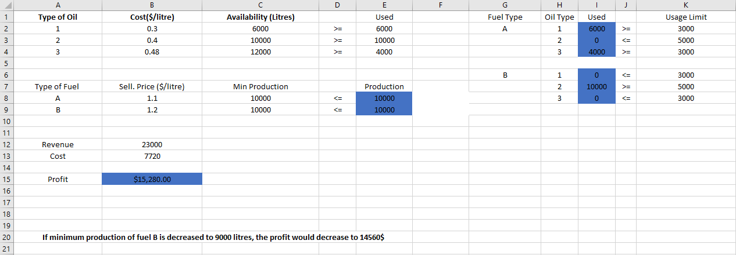***Excel Solution :*** The following solution is obtained using Excel Solver: